**Healthy Schools Plus**

**Tewkesbury School**

**Actions Taken**

**Initial concerns**

* All students followed a core curriculum which focused on fitness as well as the traditional sports.
* The quality of the food and drink provided at break and lunchtime was improved in consultation with Years 7-10.
* The teaching of health and fitness was enhanced
* Science and personal development skills teaching was improved
* Assemblies were delivered on the topic and school marketing of healthier food was improved.

Observation of poor food choices at break and lunchtime, coupled with many Year 7 pupils needing to improve their fitness, added to concerns about obesity within the school.

**Establishing a baseline**

392 students did a survey on food choices and 265 Year 7’s all completed the bleep test.

**Results**

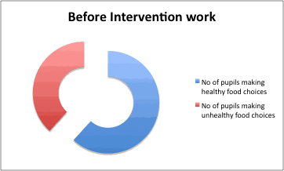

The actions led to improvements in fitness across the whole cohort including an increase in extra -curricular uptake. There was an increase in healthier food choices and a greater awareness of the need for fitness, as well as improvements in fitness levels across whole cohort of Year 7.

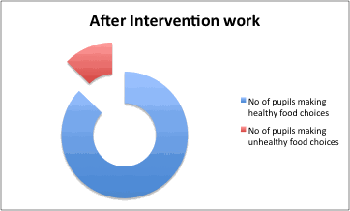

Following the intervention, just 50 out of 392 pupils identify themselves as making unhealthy choices for food at break and lunch. Work is continuing to further address these issues within the school

Before the intervention 150 out of 392 pupils identified that they did not make healthy food choices at break or lunch.